**Module (Bootstrap Basic & Advanced) – 6**

Q. What are the advantages of Bootstrap?

ANS. Bootstrap has more responsiveness and a quicker stylesheet.

* Web development is made simpler and faster with Bootstrap.
* Simple to utilize: Anyone may begin using Bootstrap with very basic HTML and CSS skills.
* Features that respond: The responsive CSS of Bootstrap adjusts to computers, tablets, and phones.
* Your website will look great on a variety of devices if you choose Bootstrap for web design, which offers a responsive grid system that automatically modifies the responsive layout dependent on the screen size.
* Bootstrap saves you time and effort when coding from scratch by providing a large variety of pre-built components, like buttons, forms, and navigation bars.
* Because Bootstrap is simple to understand and use.
* You may also customize the look and feel of your website with Bootstrap's rich customization features.
* Compatibility with recent browsers: Bootstrap 5 works with Chrome, Firefox, Edge, Safari, and Opera.

Q. What is a Bootstrap Container, and how does it work?

ANS. In Bootstrap, there are two types of containers: .container and .container-fluid.

1. .container: This class represents a fixed-width container. It provides a responsive layout by setting a maximum width based on the screen size. The width of the container adjusts as the screen size changes, providing a responsive design. The container has different fixed widths for different screen sizes, known as breakpoints.
2. .container-fluid: This class represents a full-width container that spans the entire width of the viewport. It adjusts its width dynamically based on the available screen space. It provides a fluid layout that expands, or contracts based on the browser window size.

Both container classes have built-in padding on the left and right sides to create spacing between the content and the edges of the container. This padding helps maintain consistent spacing and improves the overall aesthetics of the page.

Q. What are the default Bootstrap text settings?

ANS.

* The text style that a computer typically uses when a document is opened—such as Times New Roman—is known as the default font. It called as the default text.
* Bootstrap 5 has a line height of 1.5 and a font size of 1rem (16px) by default. Further, margin-bottom: 1rem (16px by default) and margin-top: 0 are applied to every <p> element.

Q. What do you know about the Bootstrap Grid System?

ANS. The Flexbox-built Bootstrap grid system supports up to 12 columns on a page.

* You can arrange the 12 columns together to create bigger columns if you do not want to use it all at once:
* The columns in the responsive grid system will dynamically rearrange according to the size of the screen.
* The Bootstrap grid system arranges and aligns content using a set of rows, columns, and containers. It has a flexbox design and is completely responsive.
* The responsive grid design of Bootstrap allows the columns to reorganize based on the size of the screen. Three columns of content might seem better on a large screen but arranging the content parts on top of one another would work better on a small one.

The Bootstrap 5 grid system has six classes:

1. .col- (extra small devices - screen width less than 576px)
2. .col-sm- (small devices - screen width equal to or greater than 576px)
3. .col-md- (medium devices - screen width equal to or greater than 768px)
4. .col-lg- (large devices - screen width equal to or greater than 992px)
5. .col-xl- (xlarge devices - screen width equal to or greater than 1200px)
6. .col-xxl- (xxlarge devices - screen width equal to or greater than 1400px)

Q. What is the difference between Bootstrap 4 and Bootstrap 5?

|  |  |  |
| --- | --- | --- |
| BASIS OF | BOOTSTRAP 4 | BOOTSTRAP 5 |
| Grid System | It has 5 Classes (xs, sm, md, lg, xl). | It has 6 Classes (xs, sm, md, lg, xl). |
| Color | It has limited colors. | Extra colors added with the looks, A card improved color palette. |
| jQuery | It includes all necessary plugins and jQuery. | Instead of using jQuery, vanilla JS is used together with a few functional plugins. |
| CSS | Less CSS usability. | More CSS properties also customized properties. |
| Forms | Uses default form development tools. | Better development of forms. |
| Utilities API | We cannot modify utilities in bootstrap 4 | Bootstrap 5 gave freedom to modify and create our own utility |
| Gutter | We use. glutter with font size in px | We use .g* with font size in rem |
| Bootstrap Icons | Bootstrap 4 does not have its own SVG icons. Small icon collection. | Bootstrap 5 have its own SVG icons. Large icon collection. |
| flexbox grid | This makes easier to implement vertical designs, and the columns and rows can easily be implemented. | An advanced grid system is made usable. |
| Off canvas Component | It does not support Off canvas Component. | It supports Off canvas Component |
| RTL Support | It does not enable RTL | It enables RTL |

Q. What is a Button Group, and what is the class for a basic Button Group?

ANS. In Bootstrap, "Button Groups" is a class with the name "btn-group," which is used to arrange buttons vertically or horizontally in groups (without spaces).

.btn-group = is the class for create a button group. It applies on patent tag and each child button has its own class of “btn”.

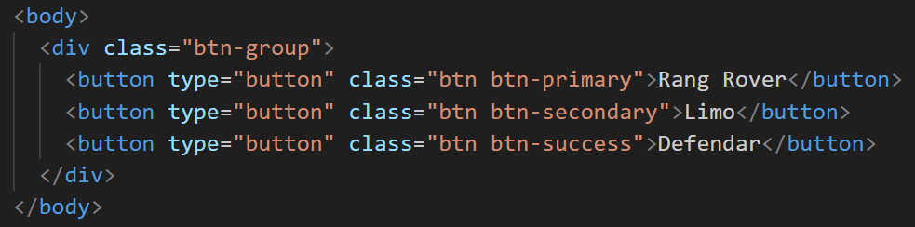

OUTPUT =

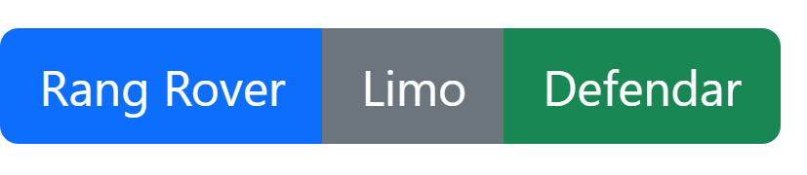

Q. How can you use Bootstrap to make thumbnails?

ANS. The .img-thumbnail class is used in Bootstrap to make thumbnails.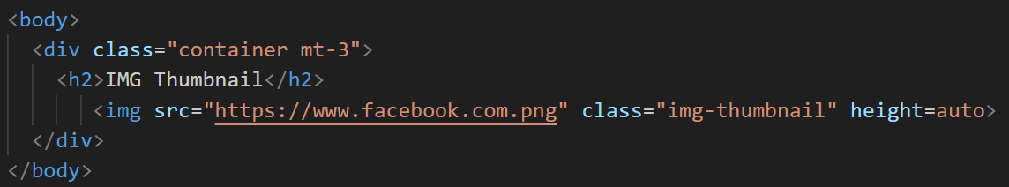

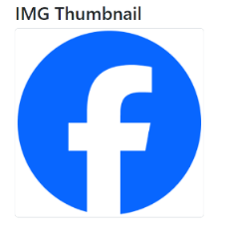

* Now that we have used Bootstrap to construct a basic HTML thumbnail, we can alter and add any material to the screen to improve its appearance.

Q. In Bootstrap 4, what is flexbox?

ANS. The primary difference between Bootstrap 3 and Bootstrap 4 is that the layout is now handled by flexbox rather than floats in Bootstrap 3.

* Designing flexible and adaptable layout structures without the need for floats or positioning is made simpler with the help of the Flexible Box Layout Module.
* Use the d-flex class to make direct children into flex items.
* Use the d-inline-flex class to generate an inline flexbox container.
* To show the flex items horizontally (side by side), use.flex-row (default).
* To align the horizontal direction to the right, use the.flex-row-reverse command.
* To show the flex items vertically, use.flex-column to reverse the vertical direction, use.flex-column-reverse.
* To adjust the alignment of flex elements, use the.justify-content-* classes. The following classes are accepted: start (default), end, center, between, and around.
* Using.mr-auto or.ml-auto, you can quickly add auto margins to flex elements.
* Use.flex-nowrap (default) flex-wrap, or.flex-wrap-reverse to control how flex items wrap in a flex container.
* It is simple to specify a certain flex class on a particular screen size because all flex classes have extra responsive classes. The symbols sm, md, lg, or xl, which stand for small, medium, large, or xlarge screens.

Q. How can one create an alert in Bootstrap?

ANS. Alerts are created with the alert class. There are four types of alerts in Bootstrap.

* alert-success, alert-info, alert-warning, or alert-danger.

INPUT = 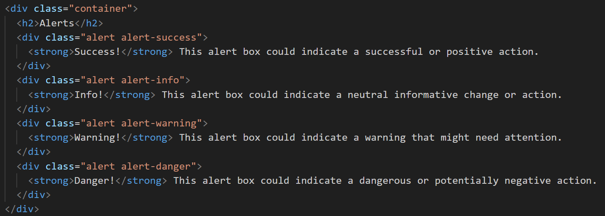

OUTPUT =

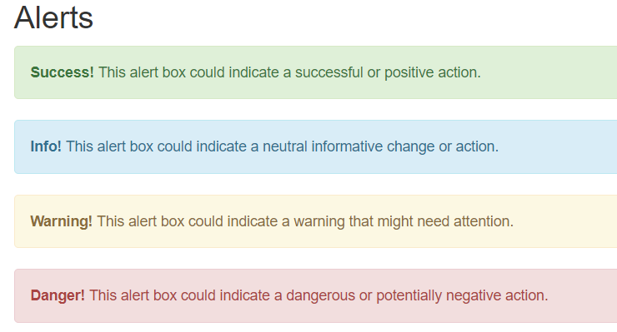

Q. What is a bootstrap card and how would you create one?

ANS. In Bootstrap 5, a card is a box with a border and padding around the contents. It has settings for content, colors, headers, footers, and other things.

* The .card class is used to generate a basic card, while the .card-body class is used for content inside the card.
* A header is added to the card by the .card-header class, and a footer is added by the .card-footer class.
* Use contextual classes (.bg-primary, .bg-success, .bg-info, .bg-warning, .bg-danger, .bg-secondary, .bg-dark, and.bg-light) to add a background color to the card.
* To position an image at the top or bottom inside the card, add .card-img-top or .card-img-bottom to a <img> tag.